**Proyek ISY6676003**

**Sistem Informasi Lappies**

Kelas: BA11

Kelompok: 7

Anggota:

1. Stefanus Abel Candra Putrano - 2602137874
2. Jason Nathanael Rusli- 2602090971
3. Brian Christoper Ongowarsito - 2602168236
4. David Supangat- 2602168690

**BINUS UNIVERSITY  
Jakarta**

**Ganjil 2023/2024**

1. Activity Diagram, Use Case Fully Description, System Sequence Diagram (LO1)

* Activity Diagram

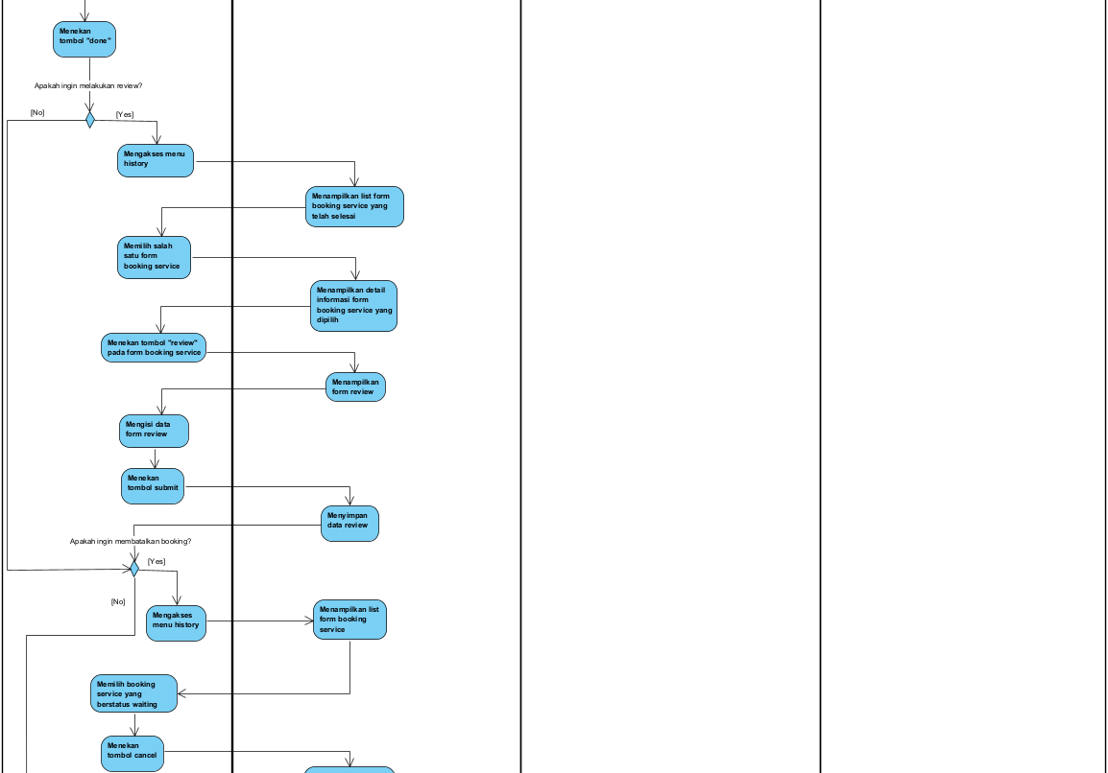

* Use Case Fully Description

* System Sequence Diagram

2. System Architecture (LO1)

|  |  |  |  |
| --- | --- | --- | --- |
| **Specification** | **Standard Client** | **Standard Application Server** | **Standard Database Server** |
| **Operating System** | Android Oreo 8.0  iOS 11 | Linux  Mac OS | Linux  Mac OS |
| **Special Software** | Play Store  App Store | Java  Swift | Oracle |
| **Hardware** | Snapdragon 845  Apple A14 Bionic  8 GB Storage 2GB RAM | 64 GB Memory  1 TB Disk Drive | 64 GB Memory  4 TB Hot Plug Disk Drive |
| **Network** | 7.2 Mbps Broadband 4G | 100 Mbps Ethernet | 100 Mbps Ethernet |

**Alasan:** Aplikasi Lappies lebih tepat menggunakan three tier architecture dengan alasan seluruh kebutuhan untuk menjalankan proses bisnisnya dapat dipenuhi oleh three tier architecture ini, kemudian juga bisa lebih hemat biaya. Selain itu, three tier architecture juga merupakan system architecture yang paling sesuai digunakan untuk aplikasi mobile.

3. Design System Input and Output (LO1)

* System Input

1. Mengisi Form Sign Up

1. Mengisi Form Booking Service Laptop

1. Mengisi Form Pembatalan Booking Service Laptop

1. Melakukan Verifikasi Form Pembatalan Booking Service Laptop

1. Mengisi Form Review

1. Mengupload Forum

1. Melakukan Reply Forum

1. Membuat Laporan Statistik Jumlah Booking Service

* System Output

4. Design Database (LO1)

1. Data Record Untuk Table “Pengguna”

|  |  |  |  |
| --- | --- | --- | --- |
| idPengguna | namaPengguna | dobPengguna | nomorTelponPengguna |
| PG08112023001 | Freddy Fandry | 12/07/2001 | 087813782784 |
| PG09112023001 | Hendra | 8/08/2001 | 081932841849 |
| PG10112023001 | Ryan David | 29/07/2001 | 085512738462 |

|  |  |
| --- | --- |
| emailPengguna | Password |
| Freddy @gmail.com | Freddy1230 |
| Hend123@gmail.com | Hend73103 |
| RyanDav@gmail.com | Ryan72781 |

2. Data Record Untuk Table “FormBookingService”

|  |  |  |  |
| --- | --- | --- | --- |
| idFormBookingService | tanggalBookingService | userAgreement | deskripsiMasalah |
| BS09112023001 | 10/11/2023 | Agree | Baterai bocor |
| BS10112023002 | 11/11/2023 | Agree | Overheating |
| BS11112023003 | 12/11/2023 | agree | Layar mati total |

|  |  |
| --- | --- |
| fotoKerusakan | status |
| Kerusakan1.PNG | Waiting |
| Kerusakan2.JPG | Cancel |
| Kerusakan3.JPEG | Cancel |

3. Data Record Untuk Table “DetailFormBookingService”

|  |  |
| --- | --- |
| idFormBookingService | idTipeKerusakan |
| BS09112023001 | TK10082020001 |
| BS10112023002 | TK10082020002 |
| BS11112023003 | TK10082020003 |

4. Data Record Untuk Table “FormPembatalanBookingService”

|  |  |  |
| --- | --- | --- |
| idFormPembatalanBookingService | tanggalFormPembatalanBookingService | alasanPembatalanBookingService |
| PB20112023001 | 20/11/2023 | Kesalahan input kerusakan |
| PB20112023002 | 20/11/2023 | Sudah dapat diatasi |
| PB22112023001 | 22/11/2023 | Ingin merubah tanggal booking |

|  |
| --- |
| status |
| Berhasil |
| Gagal |
| Gagal |

5. Data Record Untuk Table “TipeKerusakan”

|  |  |  |
| --- | --- | --- |
| idTipeKerusakan | tipeKerusakan | deskripsiKerusakan |
| TK10082020001 | Storage | Strorage penuh terus-terusan |
| TK10082020002 | Software | Software tidak bekerja dengan baik |
| TK10082020003 | Battery | Baterai bocor |

6. Data Record Untuk Table “TokoService”

|  |  |  |  |
| --- | --- | --- | --- |
| idTokoService | namaTokoService | emailTokoService | nomorTelponTokoService |
| TS11082020001 | Toko 1 | Toko1@gmail.com | 082912340857 |
| TS11082020002 | Toko 2 | Toko2@gmail.com | 087923891485 |
| TS11082020003 | Toko 3 | Toko3@gmail.com | 081132941489 |

|  |  |
| --- | --- |
| alamatTokoService | deskripsi |
| Jalan Hasanuddin | Toko dengan pengalaman 10 tahun |
| Jalan Teuku Umar | Toko berkualitas dan terjamin |
| Jalan Sudirman | Toko sejak tahun 2010 |

7. Data Record Untuk Table “Review”

|  |  |  |
| --- | --- | --- |
| idReview | rating | isiReview |
| RV24122023001 | 5 | Laptop kembali seperti semula |
| RV25122023002 | 4 | Performa laptop meningkat |
| RV26122023001 | 5 | Baterai tahan lama sesuai yang diharapkan |

8. Data Record Untuk Table “Forum”

|  |  |  |  |
| --- | --- | --- | --- |
| idForum | judulForum | isiForum | foto |
| FR12122023001 | Service | Service sangat memuaskan dan cepat | Foto1.PNG |
| FR13122023001 | Harga | Harga sangat terjangkau | Foto2.JPEG |
| FR14122023001 | Cepat | Service sangat cepat | Foto3.JPG |

9. Data Record Untuk Table “ReplyForum”

|  |  |  |
| --- | --- | --- |
| idReplyForum | isiReplyForum | foto |
| RF13122023001 | Tidak hanya itu, harga juga sangat murah | Foto4.JPG |
| RF13122023002 | Saya setuju, harga sepadan dengan service yang diberikan | Foto5.JPEG |
| RF14122023001 | Cepat dan murah | Foto6.PNG |

5. First-Cut Design Class Diagram, CRC Cards (LO2)

* First-Cut Design Class Diagram

* CRC Cards

**CRC Card Pengguna**

* Front of Card

|  |  |
| --- | --- |
| **Pengguna** | |
| Create Pengguna  Save Pengguna  Send Data to FormBookingService  Send Data to Forum  Send Data to ReplyForum | FormBookingService  Forum  ReplyForum |

* Back of Card

|  |
| --- |
| idPengguna  namaPengguna  dobPengguna  nomorTelponPengguna  emailPengguna  password |

**CRC Card FormBookingService**

* Front of Card

|  |  |
| --- | --- |
| **FormBookingService** | |
| Create FormBookingService  Save FormBookingService  Get Data Pengguna  Send Data to Review  Send Data to DetailFormBookingService  Send Data to PembatalanFormBookingService | Pengguna  Review  DetailFormBookingService  PembatalanFormBookingService |

* Back of Card

|  |
| --- |
| idFormBookingService  tanggalBookingService  userAgreement  deskripsiMasalah  fotoKerusakan  status |

**CRC Card FormPembatalanBookingService**

* Front of Card

|  |  |
| --- | --- |
| **FormPembatalanBookingService** | |
| Create FormPembatalanBookingService  Save FormPembatalanBookingService  Get Data FormBookingService | FormBookingService |

* Back of Card

|  |
| --- |
| idFormPembatalanBookingService  tanggalFormPembatalanBookingService  alasanPembatalanBookingService  status |

**CRC Card DetailFormBookingService**

* Front of Card

|  |  |
| --- | --- |
| **DetailFormBookingService** | |
| Create DetailFormBookingService  Save DetailFormBookingService  Get Data FormBookingService  Get Data TipeKerusakan | FormBookingService  TipeKerusakan |

* Back of Card

|  |
| --- |
| idFormBookingService  idTipeKerusakan |

**CRC Card TipeKerusakan**

* Front of Card

|  |  |
| --- | --- |
| **TipeKerusakan** | |
| Create TipeKerusakan  Save TipeKerusakan  Send Data to DetailFormBookingService  Get Data TokoService | DetailFormBookingService  TokoService |

* Back of Card

|  |
| --- |
| idTipeKerusakan  tipeKerusakan  deskripsiKerusakan |

**CRC Card TokoService**

* Front of Card

|  |  |
| --- | --- |
| **TokoService** | |
| Create TokoService  Save TokoService  Send Data to TipeKerusakan | TipeKerusakan |

* Back of Card

|  |
| --- |
| idTokoService  namaTokoService  emailTokoService  nomorTeleponTokoService  alamatTokoService  deskripsi |

**CRC Card Review**

* Front of Card

|  |  |
| --- | --- |
| **Review** | |
| Create Review  Save Review  Get Data FormBookingService | FormBookingService |

* Back of Card

|  |
| --- |
| idReview  rating  isiReview |

**CRC Card Forum**

* Front of Card

|  |  |
| --- | --- |
| **Forum** | |
| Create Forum  Save Forum  Get Data Pengguna  Send Data to ReplyForum | Pengguna  ReplyForum |

* Back of Card

|  |
| --- |
| idForum  judulForum  isiForum  foto |

**CRC Card ReplyForum**

* Front of Card

|  |  |
| --- | --- |
| **ReplyForum** | |
| Create ReplyForum  Save ReplyForum  Get Data Pengguna  Get Data Forum | Pengguna  Forum |

* Back of Card

|  |
| --- |
| idReplyForum  isiReplyForum  foto |

6. Sequence Diagram I: First-Cut Sequence Diagram (LO2)

7. Sequence Diagram II: Three Layer Sequence Diagram (LO2)

8. Communication Diagram, Updated Design Class Diagram, Package Diagram (LO2, LO3)

* Communication Diagram

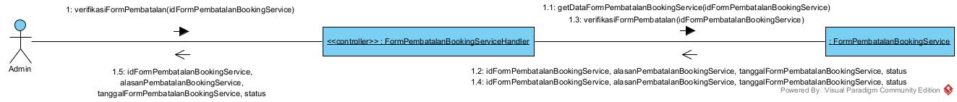

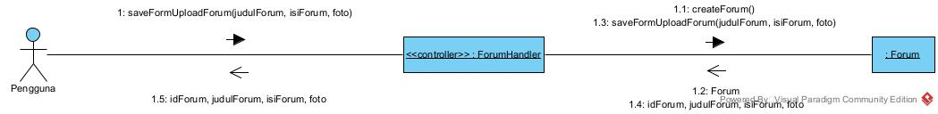

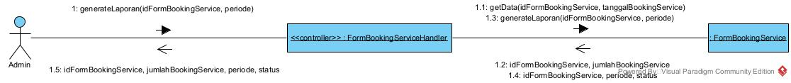

* Updated Design Class Diagram

* Package Diagram

